REPORT
ON
“2 DAY STUDENT ORIENTATION PROGRAMME ”
UNDER PROJECT
JIGYASA
(A JOINT INITIATIVE OF CSIR NEIST JORHAT & KVS GUWAHATI REGION)
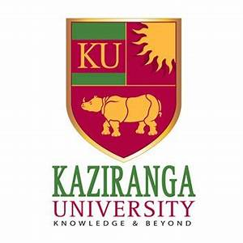
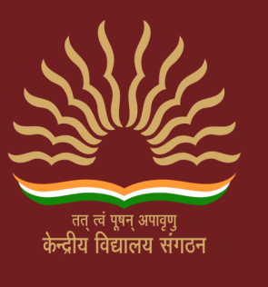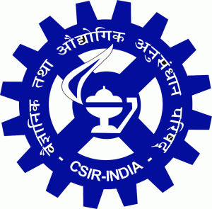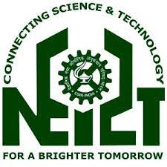

NODAL COORDINATING VIDYALAYA: KV JORHAT NO-III (RRL)

DATE: 11-12 October 2018

VENUE: CSIR NEIST JORHAT and KAZIRANGA UNIVERSITY

ASSAM 785006

RESOURCE PERSONS
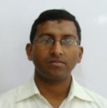
MR. D NEOG, SCIENTIST , CSIR-NEIST
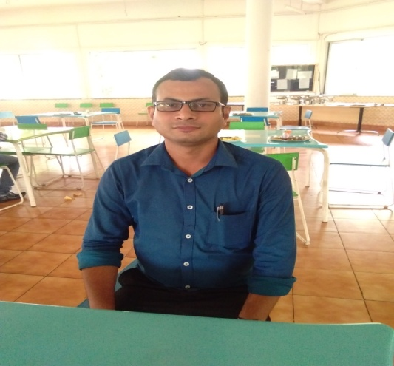
Mr dipankar neog , is working as a senior scientist, in General Engineering Division , CSIR-NEIST ,Jorhat . His specialization is mechanical designing and computational engineering. He has been awarded with the best young engineers award in 2010 by senior engineers forum of greater Guwahati .He delivered his lecture on how mathematics can be fun for the students while studying and develop logical thinking among them.

Dr. L. Saikia, Principal Scientist, CSIR NEIST Jorhat.
Dr. L. Saikia,is working as a Principal Scientist, in Material Science and Technology Division (MSTD) of CSIR NEIST Jorhat. His area of specialization is Nanotechnology and development of new tools techniques using Nanotechnology useful for mankind.He delivered his lecture on Nanotechnology to the participant which is the latest scientific innovation.
Mr M Saikia , Research Scholar , CSIR-NEIST
Mr m saikia , is working as a research scholar , in material science division who gave students an exposure to different sophisticated equipments in the different departments of CSIR-NEIST. Civil engineering , biotechnology , medicinal thermosetic plant and the bharatnagar building to learn about different instruments .
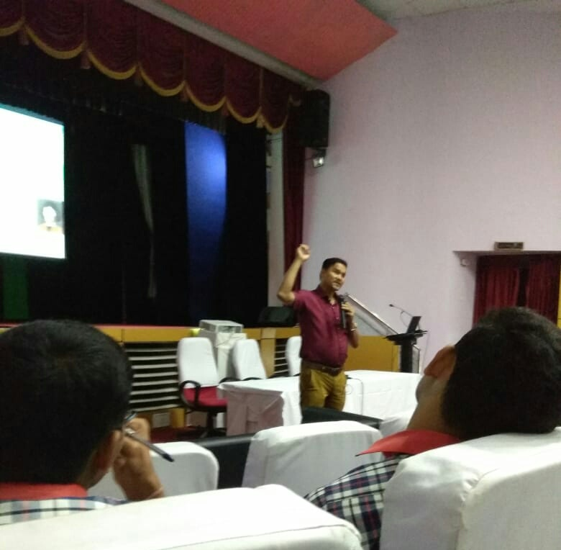

Dr PJ Chetia , Curator, Jorhat Science Center and Planetarium
Dr Prabhajyoti Chetia , the curator of the Jorhat Sc. Center and Planetarium . He is a Phd in physics and says that the center has the responsibility in bringing awareness to change habits for a better future . He delivered his lecture on astronomy which was fruitful for the students to know beyond their books and the outer space and some of its interesting facts .

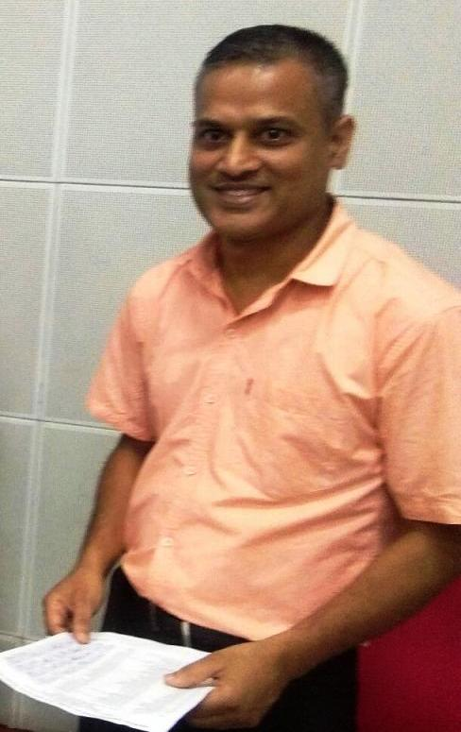

Mr P Paul , scientist , CSIR- NEIST , Jorhat
Mr. Partha Paul is working as a Scientist in Human Resource Development Division of CSIR NEIST Jorhat. He is the man from CSIR NEIST Jorhat behind the organization of the entire JIGYASA programme. He has expertise in motivational lecture and inspirational talks.
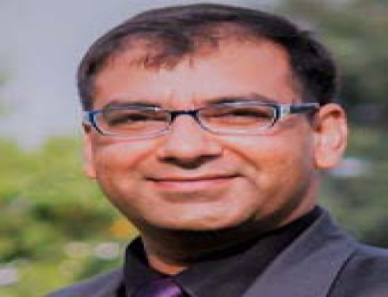
Resource Persons at Kaziranga University

Dr Aswini Kumar Dean ,SET , KU
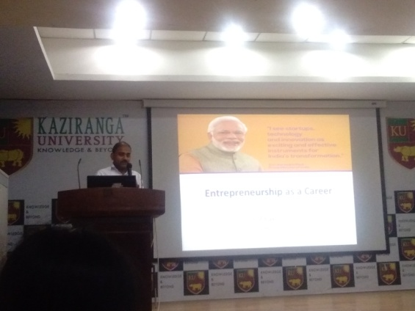
Dr Aswini Kumar , professor and dean , Ku SET and center of excellence has 18 years experience in teaching. He has completed his phd in supply chain and management . His teaching subjects are production and industrial engineering . He provided stuents the live demo of robotics and visit to engineering laboratory.

Mr Ak Chakraborty , secretary , ISVAC , Guwahati
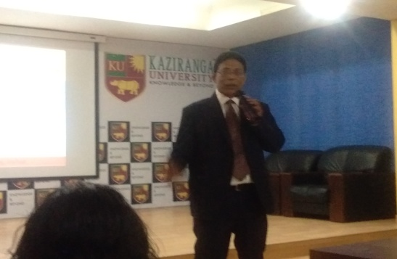
Mr Ak Chakraborty an entrepreneur who give the opportunity to the people who want to develop their startups and make career in the field of entrepreneurship . He delivered his lecture on enriching students knowledge on making career as enterprenuership .

Mr B Roy , Dean , Admission , KU
Mr Bobby Roy , Dean , Admission , KU , delivered his fruitful lecture and provided glimpses of life at higher education institute to the students . This helped the students to clear their doubts and enchaned their knowledge about their career .
REPORT ON DAY 1 ACTIVITIES (11/10/18)
Day one activities of 2 day students orientation programme under project jigyasa started with the registration of participants at JN Baurah Auditorium of CSIR-NEIST Jorhat . it was followed by inaugural session presided over by Dr. Pinaki Sengupta , Director I/C , CSIR NEIST Jorhat and Dr. MD Kehtan , Chairman , Kaziranga University . the inauguration began by lightning of lamp by the dignitaries , followed by formal welcome of the guests by traditional Assamese Gamusa . after that students of KV Jorhat No- III , RRL sang a beautiful and melodious welcome song which was applauded by all the guest . it was followed by speech by mr partha paul , scientist , csir neist , Ms IS Buragohain , Principal , KV Jorhat No-III RRL and blessings by Dr. Pinaki Sengupta , Director I/C , CSIR NEIST Jorhat and Dr. MD Kehtan , Chairman , Kaziranga University and finally a vote of thanks to CSIR-NEIST and KU .
After inaugural session two lectures were dilerverd to the students of mathematics and nanotechnology followed by laboratory visit to explore different sophisticated equipments. In the afternoon the journey headed towards kaziranga university where different programmes were arranged for the students including live demo of robotics , knowledge about career oppourtunities and glimpses of life in higher education. The programme at the university ended with an amazing movie “ The Man Who Knew Infinity “ Biograghy of Great mathematician Srinivas Ramanujan .
REPORT DAY 2 ACTIVITIES (12/10/ 18)
Day 2 started with the departure from Kaziranga University towards CSIR-NEIST where lecture was deliverd on astronomy and a talk session for different career options . These two session were very fruitful and informative for the students through which they were able to solve their problems which are faced while choosing a career option or higher education . This helped the students to know about new options and opportunities which they can go for after their senior secondary education .
After that around 3:00 PM a valedictory function was conducted by Mr. Partha Pual and preside by Mr. Kalita ,Head of MSTD , CSIR NEIST Jorhat. During valediction all the participants were given certificate of participation .

PHOTO GALLERY
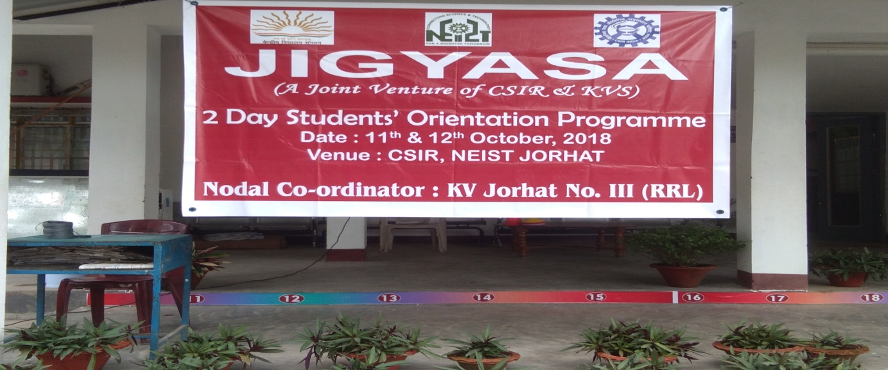

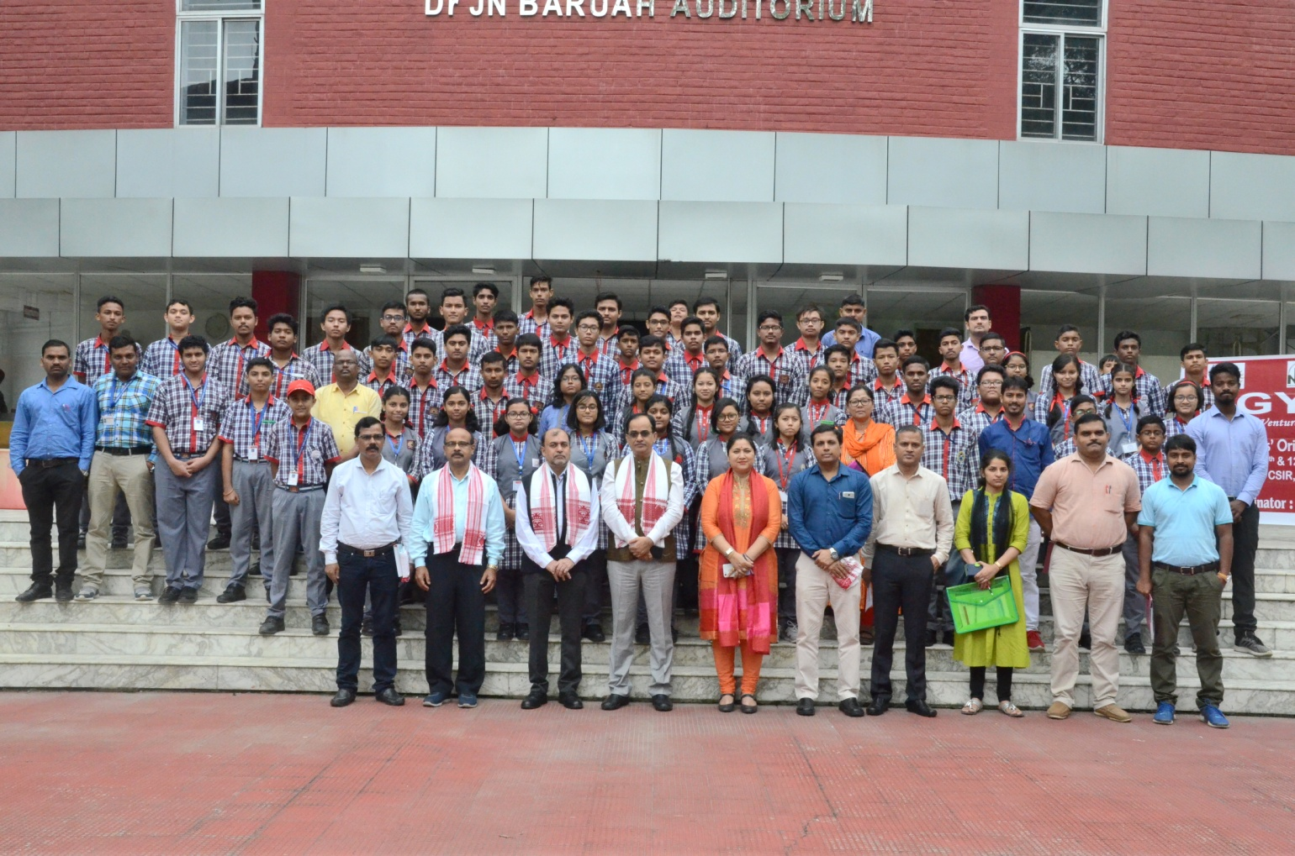

PHOTO GALLERY
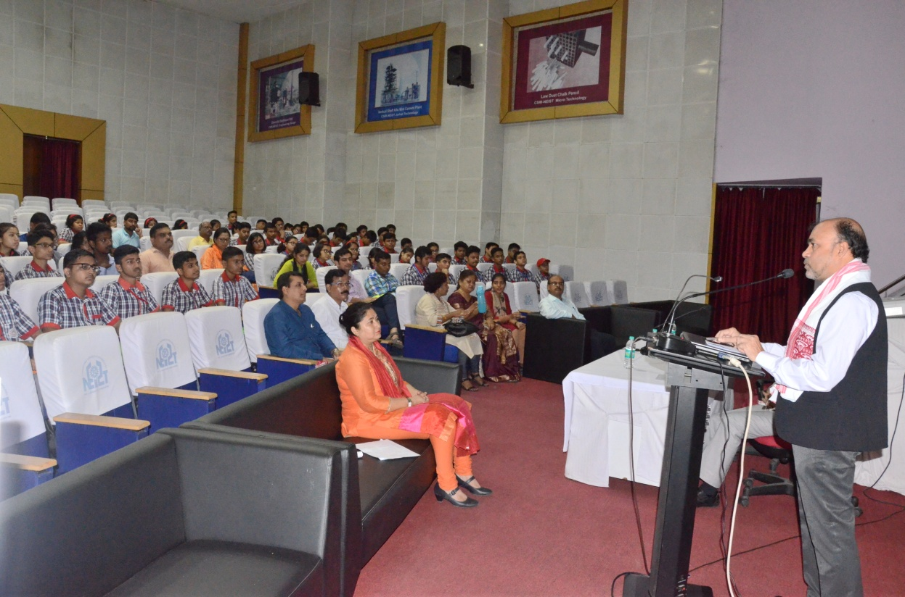

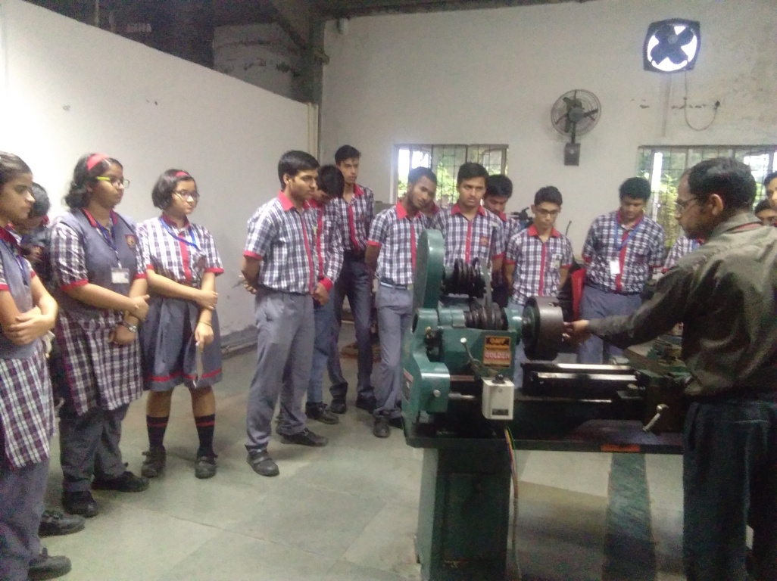

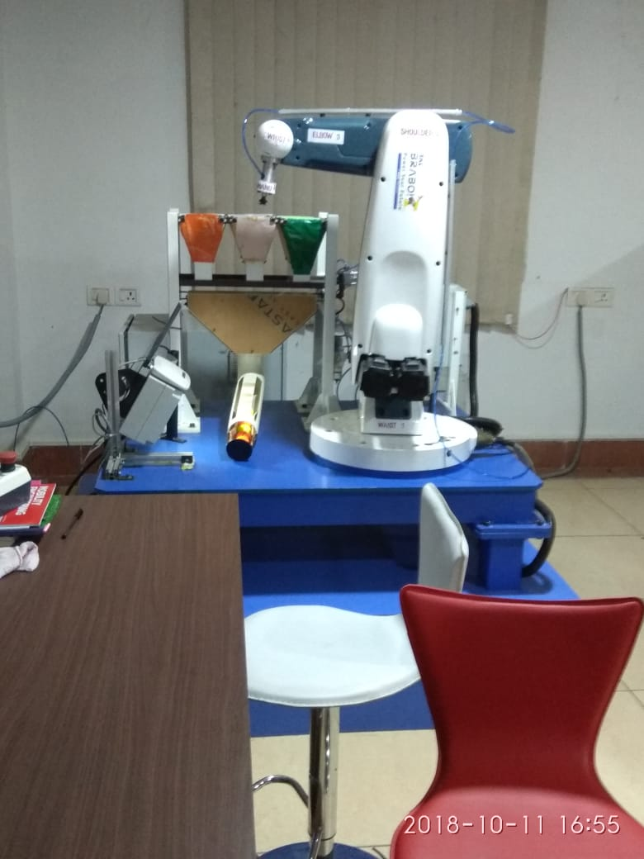
PHOTO GALLERY
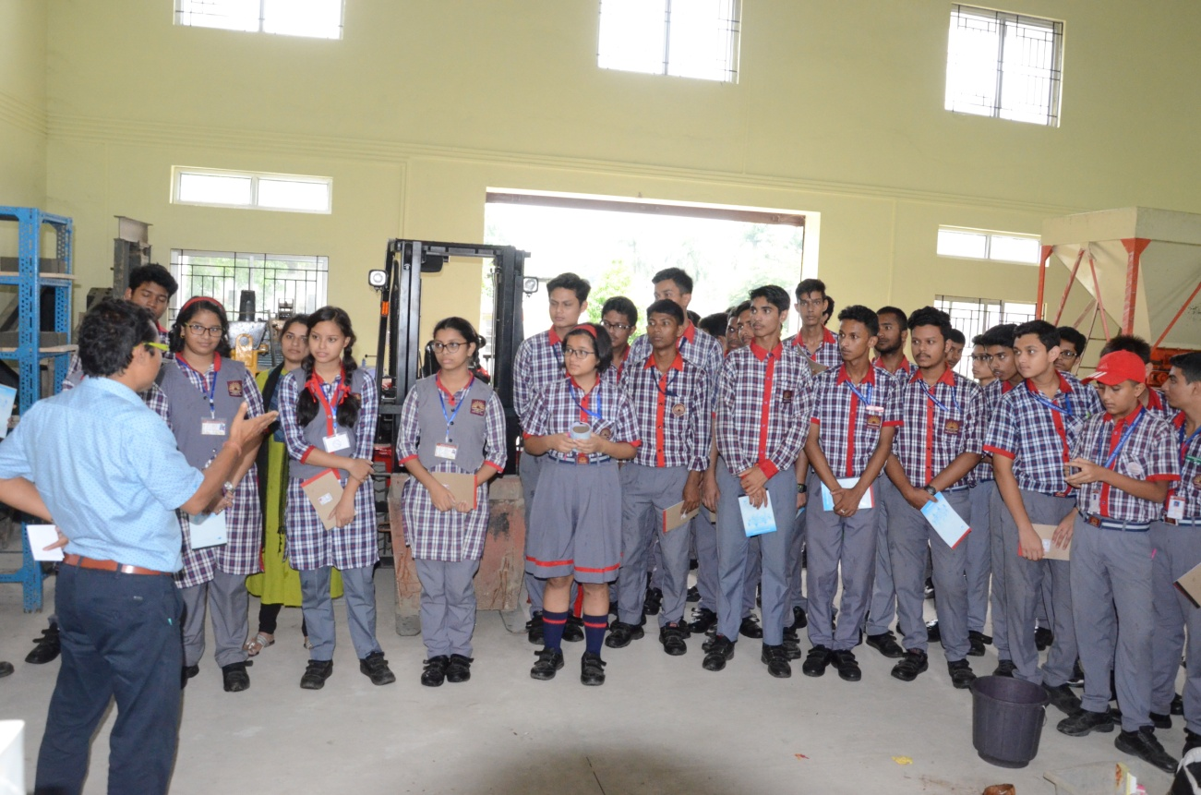

CONCLUDING REMARKS
Jigyasa, is a student- scientist connect programme. Council of Scientific and Industrial Research (CSIR), has joined hands with Kendriya Vidyalaya Sangathan (KVS) to implement this programme. The focus is on connecting school students and scientists so as to extend student’s classroom learning with that of a very well planned research laboratory based learning.
In this programme organized by CSIR NEIST, Jorhat for KVs of Guwahati Region, 10 school students participated and enriched their content and skill by the expertise of the resource persons.
Overall the programme was a successful one because the same is being reflected from the feedback of the participants.
Thank you KVS
Thank you CSIR NEIST Jorhat
Thank you KU

