KENDRIYA VIDYALAYA SANGATHAN, GUWAHATI REGION
HALF YEARLY EXAMINATION, SESSION – 2018-19
Max. Marks: 80 SUB:- Mathematics
Time:- 2 ½ hours CLASS-III
NAME: …………………………………….. ROLL NO …………….
Signature of Invigilator ………………… Signature of the examiner……………
Competencies | Marks | Grades
Concept (40)
Knowledge 20
Understanding basic concept 20
Ability to compute 20
Problem solving 20
Total 80

KNOWLEDGE:
VSA:- 1x8=8
1) Compare the numbers by the symbol >,< or =
629 620
2) Write in expanded form.
706=
3) The greatest 2 digit no. is
4)1 metre= centimeters
5) A triangle has sides.
6) Complete the pattern

7)1 day= hours
8) A dice has corners.
SA 2x6=12
- Write the smallest and the greatest 3-digit numbers without repeating the digits.
7 ,0 ,4
Smallest number Greatest number

2) Add the following
591+102 =
3) Observe the pattern and complete the addition:-
27

222 27
22
11
16

4) Subtract:-
H T O
- 8 2
- 2 2 1

5) Look at the number patterns and write the missing numbers:-
- 50 ,100 ,150 ,200 , ,
- 2 ,4 ,6 , 8, , ,

6) How many are these.
Rs 100 Rs 100 Rs 10 rupees

Understanding basic concept:
VSA 1x8=8
- 1km= m
- Write the number in word.
107 =
- Write the following in standard form.
3 Hundreds + 4 tens + 4 ones =

- Encircle the suitable unit.
Length of a pencil mm, cm ,m ,km

- Tick ( ) the object which has straight edges.

Book , Wheel , Coin rupee

- 16 less than 94 is
- comes just before 660.
- + 1 = 450

SA 2x4=8
1 ) Counting in 10’s.
110 , , , ,
450 , , , ,

2) Write two alphabets which can be divided into two similar halves. Also draw a dotted line dividing each letter into two halves.

- A shopkeeper had 200 chocolates out of which 115 were sold in a day. How many chocolates are left?
Ans.

4) Look at the following clocks and write the correct time.
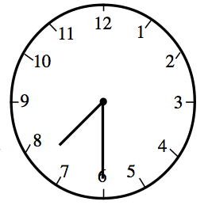
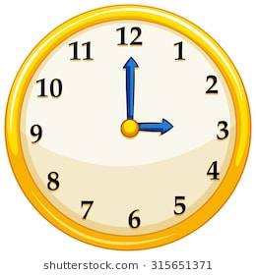

LA :- 1x4=4
1) Complete the table.
objects | Whether it has corners | Number of corners | Number of edges
Dice
egg
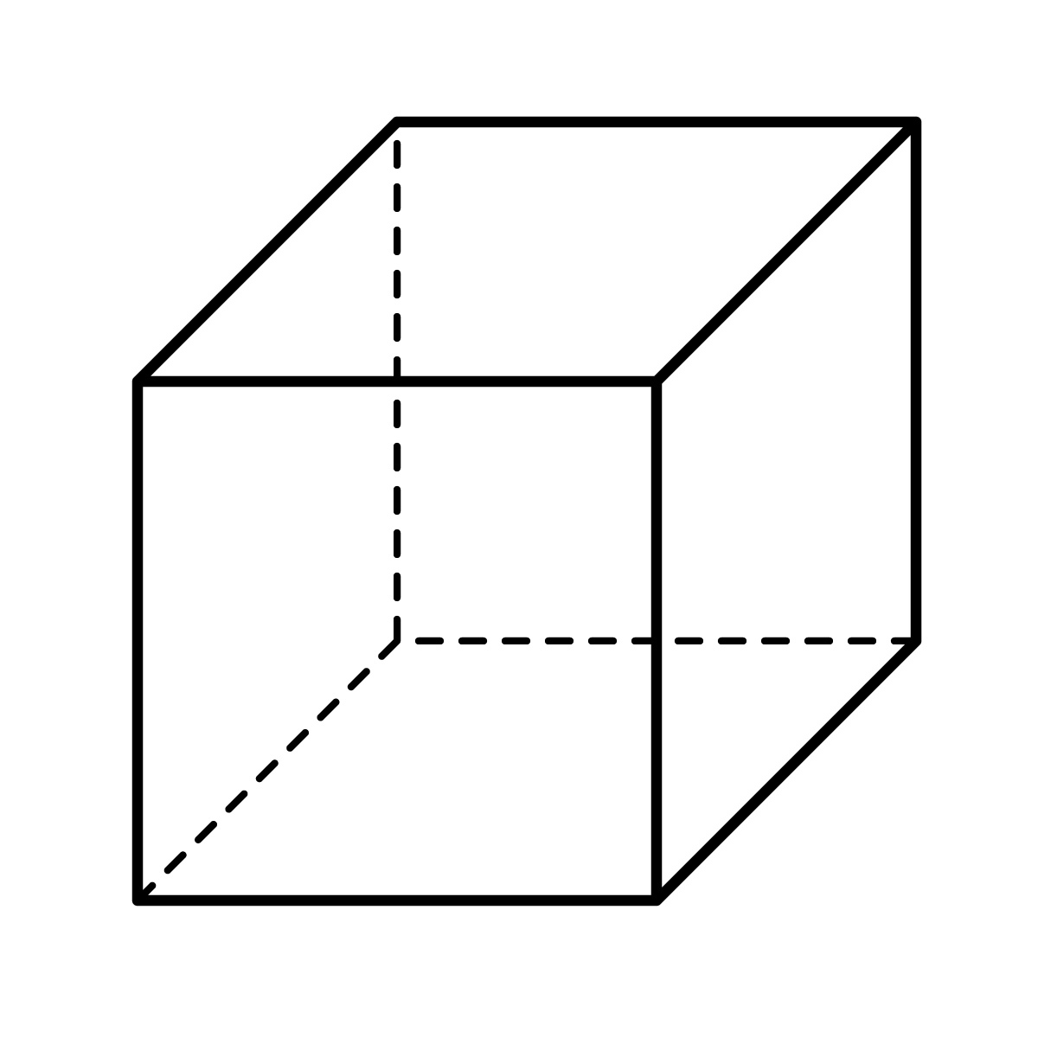

ABILITY TO COMPUTE
VSA :- 1x6=6
- The sum of 20 and 6 is .
- 1 minute= seconds.
- Write the missing numbers
280, 260, 240, ,
- A rectangle has sides.
- 100+ 80 + 1 =
- Subtract
2018-18 =

SA :- 2x5=10
- Draw a side view and the top view of a cap.
Ans.

- Colour the picture

- Green , - Red

- - Yellow , - Blue

- Complete the puzzle using addition and subtraction:-

50
50
+ =

_ =
75

- Fill in the blanks with suitable numbers

H | T | O
4 | 2 | 7
2 |  | 8
 | 7

- Draw a Rectangle.
Ans.

LA:- 1x4=4
- Which of these will be in centimeter and which will be in meter.
Width of a computer screen =
Length of a banana =
Depth of a wall =
Height of your mother =

Problem Solving:-
- VSA :-
1x6=6
- 850 - = 800
- Complete the following series

- Write in figures
Four hundred sixty four
- The smallest 3 digit number is
- 1 centimeter (cm) = millimeter (mm)
- 11 less than 66 is

SA- 2x5=10
- Arrange the following in descending order and ascending order
744 , 780 , 260 , 801
Ascending order = ……………………………………………………………………………………
Descending order=…………………………………………………………………………………….

- Draw 1 picture which can be divided into two similar mirror halves.
Ans.

- Break the number in different ways.

78
70 + 8

- In a school, there are 400 girls and 587 boys. How many total students are there in that school?
Ans.

- Solve the following
2 3 6
- 1 1 7

LA 1x4= 4
- Indu noted the electricity meter readings of her house. Last month’s reading was 118 units. This month’s reading is 190 units. How much more electricity was consumed?
Ans.

