KENDRIYA VIDYALAYA JORHAT NO-III, RRL JORHAT
AUTUMN BREAK HOLIDAY HOMEWORK (2020-21)
Class -1

English
Q1. Write the alphabet in small and capital letters beautifully.
Q2. Draw the picture of your favourite animal.
Q3. Collect the pictures and write the names of animals and their homes and paste it in your notebooks.
हिन्दी
1) घर में या आस-पास मौजूद तस्वीरों के बारे बातचीत कीजिए। उसमें क्या हो रहा है, वह तस्वीर कहाँ की है, किस बारे में, कौन क्या कर रहा है आदि। कब की तस्वीर होगी ? आप चाहें तो अपनी किताब की किसी तस्वीर पर भी बात कर सकते हैं। उस पर कोई कहानी भी बनाकर सुना सकते है। पुरानी तस्वीरों को फिर से एक बार देखिए और बताइए कि उसमे कुछ ऐसा है
जिसपर आपने पहले कभी ध्यान नहीं दिया।
2) अलग अलग आकार के पांच पत्ते इकट्ठा कर चार्ट पेपर पर चिपकाओ ।
EVS
- Paste pictures of your family members in your notebook.

- Go to your house roof or balcony with your parents and you will see from there different kinds of plants, birds, flowers and animals. Make an audio at most two minute what you have seen.
Math
Look at picture and fill in the blanks using the correct option.
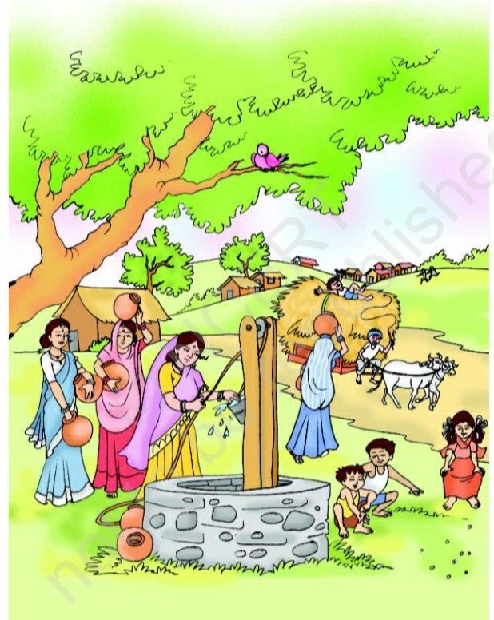
- The bird is sitting _______ ( in / on / under ) a tree.
- The bullock cart is ______ ( behind / front ) the children playing with grass.
- Women have kept pot _______ ( under / over / on) their head.
- Draw and colour the picture by making a ball in front of a cat in your notebook.

CLASS-II
SUBJECT-ENGLISH
1)Make a “Thank you “ card for those who are helping us in this difficult situation of Coronavirus.
2) Write any ten daily used things in English in your notebook.
3) Have you visited a zoo? List the animals and birds you like the most and why?
SUBJECT -HINDI
1) ( Project work)आप एक शब्द/वाक्य चून लीजिए और उससे खूब सारे और शब्द/ वाक्य बनाइए, अपने परिवार के सदस्यों से बनवाइए। जो टीम सबसे ज़्यादा शब्द बनाएगी, वही विजयी घोषित ! जैसे - अट्टू , पट्टू, मट्टू / गए मेले, खाए केले,अकेले-अकेलेआदि।h
2) " काले मेघापानी दे" और "सावन का गीत" कविता याद करके परिवार के किसी सदस्य को सुनाओ ।
3) पंचतंत्र की पांच कहानियाँ पढ़कर अपनी मनपसंद एक कहानी लिखो।
SUBJECT-EVS
Q1. Write any 5 indoor and 5 outdoor games.
Q2. Collect the picture of healthy food items and classify them as:
i) Energy Giving Food
ii) Body Building Food
iii) Protective Food
Q3. Paste the pictures and write the names of 3 National Festival and its date of celebration.

SUBJECT -MATHS
1) If your birthday party is organised at your home then how many glasses of lemon juice is needed for all? Also, how many lemons are required to make the glasses of lemon juice?
2) Make your own pattern using the waste material at your home.
3) Find out how much water is used ( in mugs or buckets) in your house for each of the following :-
a)Washing clothes
b)Bathing
c) Drinking

. CLASS-III .
SUBJECT – ENGLISH
Explore your kitchen and write the names of any ten vegetables and write an appropriate adjective before the name of the vegetable.
For example: Tasty Tomato etc.
Write few lines on ‘MY PET’.
Make a poster for your reading room like: ‘Keep Silent’,
‘Reading is a good Practice’ etc.
SUBJECT-EVS
1) Try to make a ‘Pot’ using clay.
2)Answer the following questions.
a) Write any two symptoms of Coronavirus.
b) Write any two methods by which we can prevent the spread of Coronavirus.
3)Which festival do you like the most? Write any four lines about it.
SUBJECT – HINDI
1) ( Project work) हमे मालूम है कि सभी बच्चों को कहानी / गीत सुनना और सुनाना पसंद आता है। घर के सदस्यों/ बड़ों से कहें किे मौखिक /लिखित साहित्य का इस्तेमाल करते हुए आप बच्चों को अलग-अलग तरह की उनकी पसंद की कहानियाँ सुनाए। उस तरह की कहानियाँ बच्चों के साथ साझा की जा सकती हैं। जिनमें कहानी के साथ साथ गीत या कविता की पंक्तियाँ भी होती थीं। आम तौर पर बच्चे ऐसी कहानियाँ कम ही सुनते हैं।
2) तराजू से तोलनेवाले दस चीजों के नाम लिखो।
3) कुतरने वाले पांच जानवरों के नाम लिखो और उनके चित्र चिपकाओ।
SUBJECT – MATHS
Irfan’s mother is twice as old as him. She is also 20 years older than him. Guess the ages of Irfan and his mother.
Make your own story problem for the following: -
36 men and 52 women waiting for their turn to vote.
The post office is 1 kilometre from Shahid’s home and 2 kilometres from his school.
Make a working clock out of waste material available at home.

CLASS-IV session- 2020-21

SUBJECT - ENGLISH
Q1. Discuss with your parents the sport they used to play and write few lines on your favourite sport/game and also draw/paste its picture.
Q2. Write few lines on Imprtance of Trees.
Q3. Pick up any newspaper in English and attempt to read the headlines on every page like international news, sports etc. and paste any 5 headlines in your English notebook.

SUBJECT-EVS

1. Grow any spice/medicinal pant/herb in a pot, You must know it’s health benefits, nurture it. When the school will open bring it back to school. Share it’s health benefits with your classmates.
2. What precaution should be taken to prevent Coronavirus?
3. Make a collage of ‘Save Environment’. Collect pictures from your old books and newspapers. (On chart paper/Drawing sheet)

SUBJECT- HINDI
1) ( Project work)पसंद क विषय पर पोस्टर, विज्ञापन बना सकते हैं, सूचना लिख सकते है , जैसे- कोरोना की रोकथाम के लिए घर में रहने की सलाह देना, इससे जुड़ी जरूरीबातों की सूची बनाना ।
2) दानवीर कर्ण के बारे में पांच वाक्य लिखो।
3) नीचे दिए गए विषय के बारे में तीन- तीन वाक्य लिखो:-
क) स्वतंत्रता
ख) सत्याग्रह
ग) खादी
घ) चरखा

Maths

1.Imagine if you go to a medical shop and buy an ointment, then what all necessary points you need to remember before buying the medicine? What may happen if you ignore to observe these points?

2. Chelanur village has a milk society. Geetha and Ammini went there to buy 4 litres of milk. But the man could not find the one litre measure. He had only a 3 litre and a 5 litre bottle with him. But he gave them exactly 4 litres of milk. Explain how he did this.

3. Find your own way to make a bottle which can measure 200 ml, 600 ml and 1 litre

CLASS V SESSION ( 2020-2021 )
ENGLISH

EVS
1)How can we contribute to make the world clean and beautiful? Write any five simple Ideas.
2)Make a list of some points on how you are boosting your Immunity to fight with Covid-19.
3) Try to make a model of ‘The Earth’ with the help of the material which is available at home.

HINDI
प्रश्न 1 पानी हमारी ज़िन्दगी में महत्वपूर्ण तो है ही , मुहावरे की दुनिया में भी उसकी खास जगह है । पानी से सम्बन्धित कोई तीन मुहावरे लिखो और उनका उचित संदर्भ में प्रयोग करो।
प्रश्न 2 कोई भी एक कहानी और एक कविता लिखो ( स्वंय रचित ) |
प्रश्न 3 बीस शब्दों को अर्थ के साथ लिखकर एक छोटा – सा शब्दकोश बनाएँ | चाहें तो इस शब्दकोश में चित्र भी बना सकते हैं |

Maths
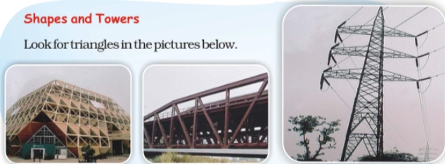
Children do all the following questions in your maths notebook.

1.Guess why triangles are used in these towers, bridges etc.? Look around and find more places where triangles are used.
2. Lata bought a pencil and a pen for seven and a half rupees. She gave Rs. 10/-. The shopkeeper gave back the money in half and quarter rupees. What are the coins she got?
3. Make your own fraction strips using different sizes and coloured papers. Compare the strips into different fractions.

