# HOLIDAY HOME WORK FOR CLASS X (ALL SUBJECTS)







**HOLIDAY HOME WORK FOR CLASS X (MATHEMATICS)**

**1. State the Basic Proportionality Theorem and prove it.**

**2. Write the converse of Basic Proportionality Theorem and prove it.**

**3. Prove that if a perpendicular is drawn from the vertex of the right angle of a right triangle to the hypotenuse, the triangles on each side of the perpendicular are similar to the whole triangle and to each other.**

**4. Prove that in a right triangle, the square on the hypotenuse is equal to the sum of the squares on the other two sides.**

**5. Prove that the tangent at any point of a circle is perpendicular to the radius through the point of contact.**

**PROJECT/ACTIVITY (ATTEMPT ANY ONE)**

**A1. To verify the conditions of consistency/ inconsistency for a pair of linear equations in two variables by graphical method.**

**A2. To identify Arithmetic Progressions in some given lists of numbers (patterns).**

The **evaluation of the project/activity** will be based on the following Rubrics:-

|  |  |  |
| --- | --- | --- |
| **S. No.** | **Item** | **Marks** |
| **1** | **Quality & Lay out of the project.** | **10** |
| **2** | **Visual Presentation of the facts like Description/Content/ Picture/Map/Graph/Diagram/ Derivation etc.** | **20** |
| **3** | **Overall Presentation (Neatness, Handwriting and word limit etc.)** | **10** |
| **4** | **Assessment of the Project through Questionnaire (Google Form-10 MCQ or telephonic viva/ any other suitable methodology )** | **10** |
|  | **Total** | **50** |

**COMMON LAY OUT OF MATHEMATICS – PROJECTS**

1. **Cover Page**
2. **Certificate**
3. **Table of contents – Page Title**
4. **Title /topic of the Project**
5. **Objective of the Project.**
6. **Brief description of the project.**
7. **Pre requisite Knowledge.**
8. **Material / Resources required.**
9. **Planning /Procedures followed.**
10. **Mathematical Concept(s) Used.**
11. **Results (Analysis /Interpretation etc.)**
12. **Conclusions.**
13. **Acknowledgement.**
14. **List of references.**

**Note: You may add any other relevant points as per your project allotment.**

**\*\*\*\*\*\*\*\*\*\*\*\*\*\*\*\*\*\*\*\*\*\*\*\*\*\*\*\*\*\*\*\*\*\*\*\*\*\*\*\*\*\*\*\*\*\*\*\*\*\*\*\*\*\*\*\*\*\*\*\*\*\*\*\*\*\*\*\*\*\*\*\*\*\*\*\*\*\*\*\*\*\*\*\*\*\*\***

**PHYSICS ASSIGNMENT FOR AUTUMN-BREAK:(PHYSICS)**

**PRACTICE Work**: (in class work copy)

1. Relation between Commercial unit of energy and Joule.
2. Magnetic effects of current: SNOW rule, Thumb rule.
3. Magnetic field lines, properties and No two magnetic field lines intersect each other.
4. Draw magnetic field lines pattern for a straight current carrying wire, current loop, solenoid.
5. Force on a current carrying conductor, Flemings left hand rule.

**PROJECT WORK:**

**Perform a study and paper work on:**

-Principle and Working of Electric Motor.

Or

-To calculate the Electricity Bill of three of the neighbours and compare and analyze the electricity consumption by three neighbours with your own house E-Bill.

**The evaluation of the project/activity will be based on the following Rubrics:**

|  |  |  |
| --- | --- | --- |
| **S.No.** | **Item** | **Marks** |
| **1** | **Quality & Lay out of the project.** | **10** |
| **2** | **Visual Presentation of the facts like Description/Content/ Picture/Map/Graph/Diagram/ Derivation etc.** | **20** |
| **3** | **Overall Presentation (Neatness, Handwriting and word limit etc.)** | **10** |
| **4** | **Assessment of the Project through Questionnaire (Google Form-10 MCQ or telephonic viva/ any other suitable methodology)** | **10** |
|  | **Total** | **50** |

**COMMON LAY OUT OF PHYSICS– PROJECTS**

1. **Cover Page**
2. **Certificate**
3. **Table of contents – Page Title**
4. **Title /topic of the Project**
5. **Objective of the Project.**
6. **Brief description of the project.**
7. **Pre requisite Knowledge.**
8. **Material / Resources required.**
9. **Planning /Procedures followed.**
10. **Scientific Concept(s) Used.**
11. **Results (Analysis /Interpretation etc.)**
12. **Conclusions.**
13. **Acknowledgement.**
14. **List of references.**

**Note: You may add any other relevant points as per your project allotment.**

**AUTUMN BREAK HOWMWORK**

**CLASS X – SCIENCE (Chemistry)**

1. **Why does carbon form compounds mainly by covalent bonding?**
2. **Define Allotropy. Give examples.**

**3. Draw the Lewis dot structures for the following molecules**

**a. NH3**

**b. H2S**

**c. PH3**

**d. C2H6**

**e. PCl5**

**f. F2**

**4. Count the number of covalent bonds present in the above molecules.**

**Project:**

**1. Prepare flash cards of any ten elements highlighting their symbol atomic number, atomic mass electronic configuration and electron dot structures.**

**OR**

**Allotrops of Carbon**

**GENERAL INSTRUCTION:**

1. **Project report should have minimum 10 pages & maximum 20 pages excluding photo gallery.**
2. **You can use net or other sources for gathering information but don’t do copy paste work.**
3. **Use A4 size white page (one side) for writing project.**
4. **The color combination should be red-black/red-blue for heading text.**
5. **The last date for submission of project 31/10/2020.**
6. **Each report must be accompanied with photo gallery with minimum six photographs indicating your involvement in performing the project work.**

**\*\*\*\*\*\*\*\*\*\*\*\*\*\*\*\*\*\*\*\*\*\*\*\*\*\*\*\*\*\*\*\*\*\*\*\*\*\*\*\*\*\*\*\*\*\*\*\*\*\*\*\*\*\*\*\*\*\*\*\*\*\*\*\*\*\*\*\*\*\*\*\*\*\*\***

**KENDRIYA VIDYALAYA, JORHAT NO-III RRL**

**AUTUMN BREAK ASSIGNMENT, BIOLOGY, CLASS-X, 2020-21**

Q.1. Why is it necessary to separate oxygenated and deoxygenated blood in mammals and birds?

Q.2. How is small intestine designed to absorb digested food?

Q.3 Label the Diagram of Respiratory System

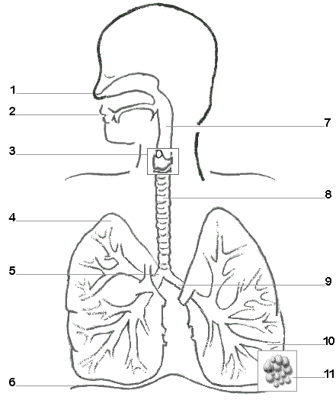

**Q.4 Photosynthesis-Crossword Puzzle**

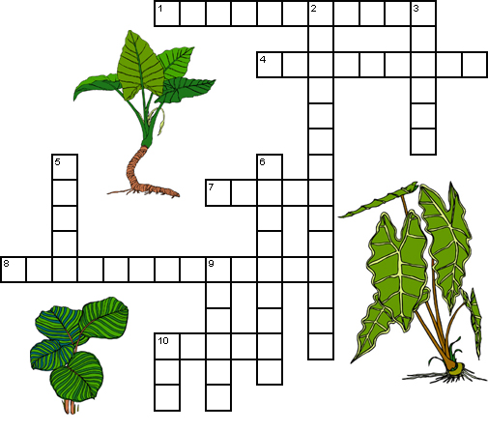

|  |  |
| --- | --- |
| **Across**  **1** A plant pigment that absorbs sunlight. (11)  **4** The links between the energy that carnivores get from eating to the energy captured by photosynthesis. (4,5)  **7** Chlorophyll absorbs every color of sunlight except this. (5)  **8** A compound needed for photosynthesis. (6,7)  **10** The product of photosynthesis. (5) | **Down**  **2** The process by which plants and some bacteria use the energy from sunlight to produce sugar. (14)  **3** Part of the plant where photosynthesis generally occurs. (6)  **5** A compound needed for photosynthesis. (5)  **6** An animal that eats plants. (9)  **9** A by-product of photosynthesis. (6)  **10** Number of molecules of oxygen produced along with one molecule of sugar. (3) |

***********************************************************************************************

**HOLIDAY HOME WORK FOR CLASS 10(SST)**

Q 1 ‘Indiscriminate use of resources had led to numerous problems’. Justify this statement

Q 2 Explain the resource on the basis of origin and exhaustibility.

Q 3 What is Agenda 21? List its principles.

Q 4 Describe the process of unification of Germany.

Q 5 ‘In India, some region are rich in certain type of resources but deficient in some other resources’. Support your answer with the examples.

Q 6 What are the stages of resource planning in India?

Q 7 What is soil erosion? Write any three human activities that leads to soil erosion.

Q 8 What is meant by sustainability of development?

Q 9 What steps can be taken to promote soil conservation?

Q 10 Why do persons have different notions of development?

Q 11 What is per capita income? How is calculated? Why is per capita income not an adequate indicator of economic development of a country? Explain.

Q 12 What is human development index( HDI) ?

Q 13 Explain any three different bases of comparison for economic development of different nations / states.

***************************************************************************************



***********************************************************************************************

**Holiday Project for Class -X**

**Sub: WORK EDUCATION**

**Task 1. Make a 4- FOLD FILE COVER (Standard Size).Using art paper (colour) and card board/hard board / materials available at home .**

**Task2. Write Bio.- Data in a A- size paper (keep in the file cover) as follows:**

**Bio-Data**

**----------------**

**1. NAME:-**

**2. MOTHER,S NAME:**

**3. FATHER,S NAME:**

**4. D.O.B:**

**5. SEX:MALE/FEMALE**

**6. AGE AS ON (20/10/2020)**

**7. EDUCATIONAL QUALIFICATION: ( in tabular format)**

**Sl.no/Qualification/Board/Name of institutions/year of passing/marks obtained/ max.mark/ percentage of marks/ Class(1st/2nd/3rd).**

**8 .Any other qualifications:**

**9. Experience:(if any):**

**The above information are true to the best of my knowledge.**

**Signature:**

**Name:**

**Date:**

**\*\*\*\*\*\*\*\*\*\*\*\*\*\*\*\*\*\*\*\*\*\*\*\*\*\*\*\*\*\*\*\*\*\*\*\*\*\*\*\*\*\*\*\*\*\*\*\*\*\*\*\*\*\*\*\*\*\*\*\*\*\*\*\*\*\*\*\*\*\*\*\*\*\*\*\*\*\*\*\*\*\***

**Class IX & X**

**Computer - Write short notes about "Cyber crime & Cyber Safety " and prepare a drawing in own your way for represent the same.?**