ग्रीष्म कालीन अवकाश गृहकार्य कक्षा vi (2020)
केन्द्रीय विद्यालय जोरहाट क्रमांक – 3(आर आर एल) असम

संस्कृत –vi
पाठ-1 – शब्द्परिचय:-I से कोई पांच चित्र संस्कृत पुस्तक से बनाए और संस्कृत में लिखें |
पाठ 2 – शब्दपरिचय:-II का सम्पूर्ण अभ्यास कार्य चित्र सहित कीजिये |
हिन्दी – vi
प्रश्न -1 “वह चिड़िया जो ”पाठ के आधार पर बताओ की चिड़िया को किन किन चीजों से प्यार है ?
प्रश्न -2 लेखिका बचपन में इतवार की सुबह क्या क्या कम करती थी ?
प्रश्न -3 “गुरु की महिमा” पर 150 में एक अनुच्छेद लिखिए ?
प्रश्न -4 “ गंगा ” और “सूर्य” के पांच - पांच पर्यायवाची लिखिए
science - vi
Ques1: List out different parts of plant that serve as food. Give two examples for each.
Ques2: Depending on what do animals eat we have classified animals as Herbivores, Carnivores and Omnivores. Define all these terms.Also, give two examples for each.
Ques3:Activity: SPROUT-MAKING (CLICK PHOTO AND PASTE IN THE HOLIDAY HOMEWORK)
Ques4: What are nutrients?What are the five major nutrients of our food?
Ques5: Write in brief the activity/test that is discussed in the chapter to confirm the presence of protein in food. (read NCERT book).
SST- VI

1.Draw a picture of Dr.B.R.Ambedkar and write his contribution towards Indian society.
2.Collect some waste materials available at home and make a useful thingh to be used in classroom .
Maths-VI

1.Fill in blank (a) 1crore = …..ten lakh
(b)1 coroe = ….. million
2.Whichis the smallest whole number and natural number ?
3.Write the factors of 23 ?
4.Find by Distributive property 5437 x1001
5.Esimate (i)12,904+2,888
(i)28,292-21,496
6.The town newspaper is published every day .one copy has 12 page.Everyday 11,980 copies are printet everyday ?
English - vi

- Look at the pictures given below and write short paragraphs.
  - B)
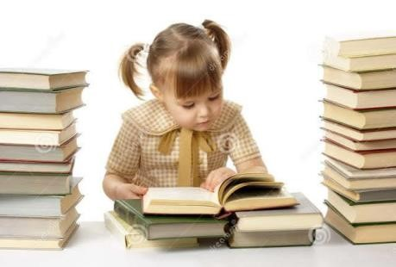

- Write a beautiful story on your own choice in cursive Handwriting and underline the NOUNS.

- Reading of textbook –
A)Honeysuckle B) A pact with the sun

